Technical Report: AI-powered SysML Diagram Generation System

  - Executive Summary
This report gives a clear technical summary of a software tool designed to create SysML diagrams automatically. Instead of drawing them by hand, users can describe a system in plain language, and the tool turns those words into proper diagrams. Behind the scenes, it brings together modern web tools, smart language models, and structured data storage to make this possible.
The main goal is to make it easier to create SysML diagrams, which are widely used in systems engineering to show how a system is built and how it works. Making these diagrams by hand can be accurate, but it often takes a lot of time and may lead to errors, especially when working on big or frequently changing projects.
Automation in this context reduces the need for extensive manual input. Engineers provide system descriptions in plain language, and the system produces corresponding diagrams that accurately capture structural and behavioral elements. This solution helps users work faster.
The system is built to be easy to use, even for those with no background in SysML. This opens the door for more people to join the design process, making collaboration smoother and speeding up idea development and testing.

  - Introduction:
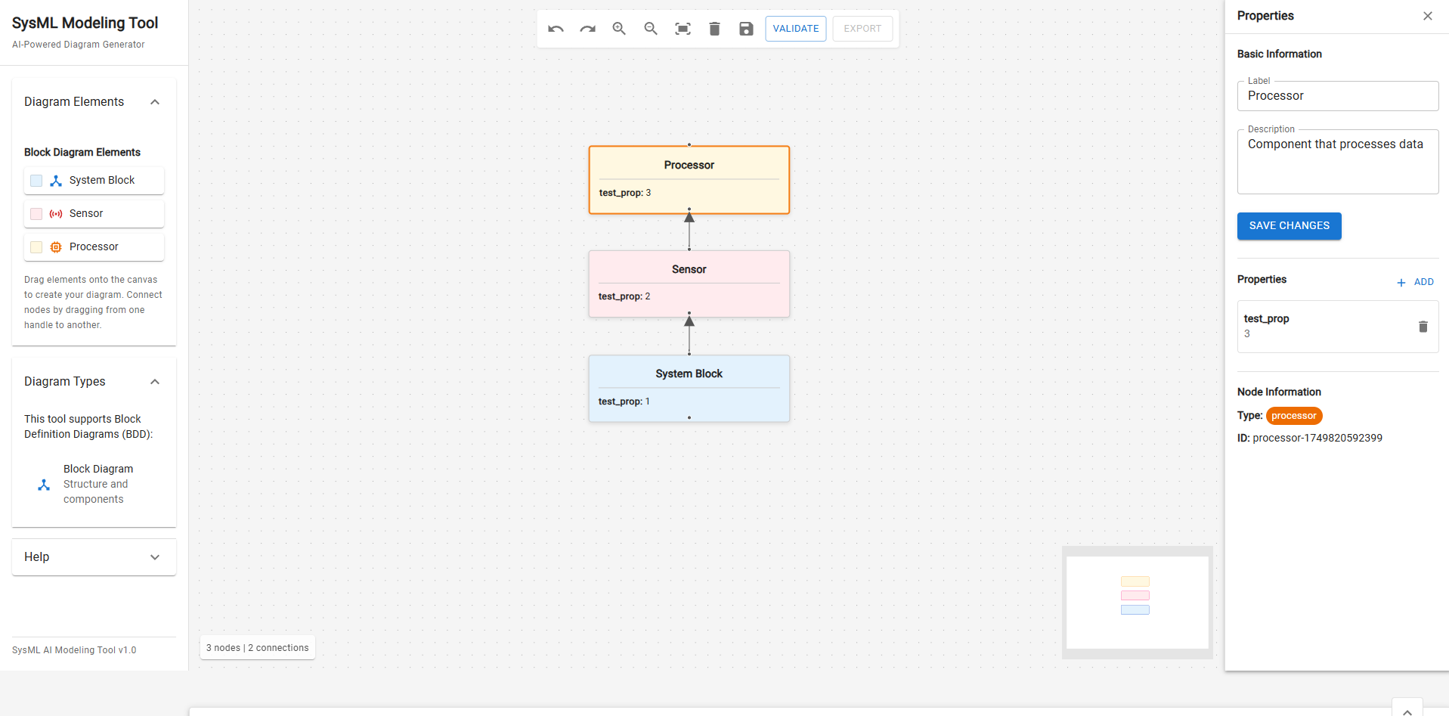
Image 1. Interactive SysML diagram editor with manual editing support, node properties panel, and visual layout Canvas.
SysML diagrams hold significant importance in systems engineering. They serve as visual tools for representing the structure, behavior, and relationships within complex systems. Such diagrams allow to engineers and non-technical stakeholders to better understand how various pieces of a system play together. For example, in safety-critical communities such as aerospace or healthcare, a SysML diagram might show how embedded software modules interface with physical sensors or actuators.
At present, these diagrams are created by hand using special modelling tools. While this approach gives complete control over the structure of a diagram, it is often slow and error-prone. For large-scale systems or frequently changing requirements this can be particularly problematic.
Accuracy and consistency are essential, even for seasoned professionals. Inevitably they face challenges when updating or maintaining complex models under tight deadlines. Our approach improves this situation. It provides a rich hybrid environment for manual and AI-assisted generation of SysML diagrams. Users can choose between constructing diagrams manually via an interactive visual interface or alternatively describe their systems in plain English.
This setup gives both flexibility and speed. Manual editing is helpful when details matter and full control is needed. From another side the AI-assisted solution is quicker and works well for early drafts. It helps reduce mistakes, so engineers can spend more energy thinking about the system itself rather than how to draw it.
  - System Architecture:
By utilizing a client-server architecture, differentiates the user interface from core computational logic. On the client side, a whole set of new technologies were utilized. For the frontend, React and TypeScript are chiefly employed. To create a flexible and interactive environment for working with diagrams, it makes use of the ReactFlow library. Users can manually create, edit and view SysML diagrams using this visual interface.
The frontend calls the backend through a set of well-defined API endpoints. These endpoints are managed by a FastAPI-based server which boasts high performance and support for asynchronous operations, ideal for real-time interaction and scalable workflows.
The system uses PostgreSQL as its main database. To handle semantics and vector embeddings, it extends the database with the pgvector extension. This allows for efficient similarity searches and retrieval based on embedded representations of text or system components.
Additionally, the backend integrates large language models provided by OpenAI, which are used to interpret natural language descriptions and assist in generating the corresponding diagram structures. The backend is responsible for orchestrating these models and encoding the rules needed to convert textual inputs into diagram entities with structure.
By separating the user interface from the data layer and API agreement, we keep our infrastructure modular and maintainable. By taking this posture, the current model also provides an opportunity for future expansion-e.g., integrate new AI models or support other types of diagrams.
  - Backend Implementation
The backend is built on the FastAPI framework, which provides a bare-bones yet effective foundation for building scalable and modular APIs.
Its structure is geared towards support of the Separation of Concerns principle, making system itself both maintainable and extendable.
At the heart of the backend is the main application entry point. This component is responsible for setting up key middleware services, such as CORS policies, authentication layers, and a logging mechanism. It also establishes connections to the PostgreSQL database at startup time, so that all of us downstream modules can have access to persistent storage when we need it.
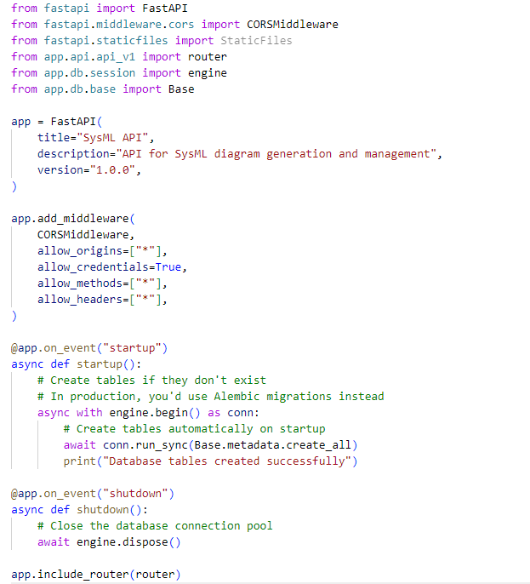
Image 2. Main FastAPI backend entry point showing application setup, middleware configuration, database connection, and lifecycle event handlers.

One of the core components of the backend is the AI-enabled diagram generation module. This module covers the basic processing that occurs when a user's input text is given as input to such a system and the meaningful diagram elements constructed from it. When a user sends in a natural language description of the system, the module formulates a prompt that can be processed by OpenAI language models. This prompt must contain all necessary formatting and context (or even constraints) in order to ensure accurate generation.
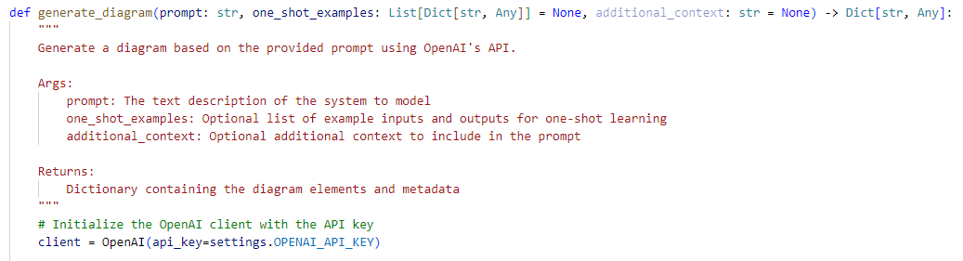
Image 3. Diagram generation function using OpenAI’s language model, with support for contextual examples and additional prompt customization.
When the language model responds with the generated JSON structure, the back end checks its validity. This step is important because it ensures that the data complies with expected formats and includes all required elements for a SysML diagram to be constructed. Any inconsistencies or gaps in the data are dealt with delightfully, either by fallback logic, or else by asking the user to clarify things.
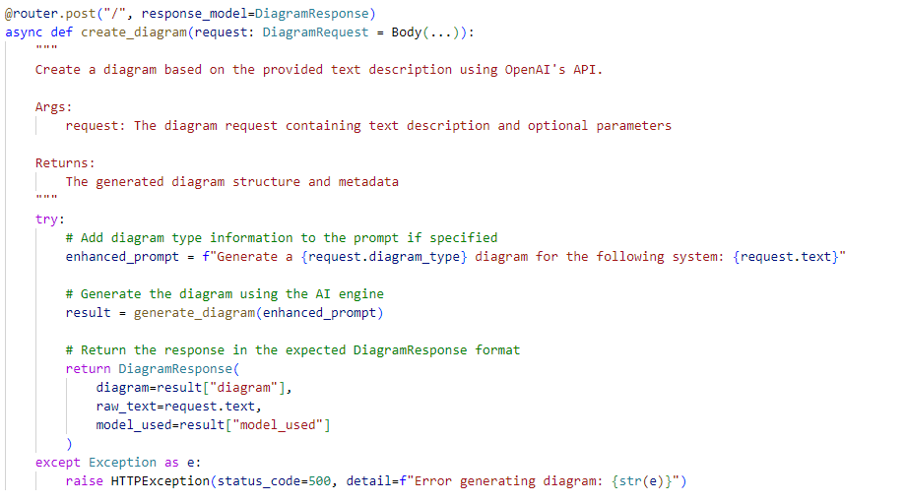
Image 4. FastAPI route handler for diagram creation, which prepares the prompt, invokes the AI model, and returns the structured diagram response.

After a diagram has been validated the automatic layout algorithms arrange the components. These algorithms are designed to maintain clarity of visual presentation and logical flow (even for complex diagrams). The result is a well-structured though rectangular form - easily catchable by eye on the front-end.

  - Retrieval-Augmented Generation
The Retrieval-Augmented Generation (RAG) module is one of the signs that the consistency and coherence of AI-generated SysML diagrams is improving. This component provides examples from a knowledge base that fit within the topic and can thus be included in response to occurrences of 'a prompt' voice.
Vectors are used as the representation for embeddings of previous diagrams into the actual overall set in this system. By doing this several representation schema are available, such as (but not limited to) building relations between different pairs of objects in order to represent them as nodes on a map; and many more. These vector stoRAGe records all there vector within PostgreSQL database, with pgvector as well.
This setup allows to efficiently look for semantic similarity among large volumes of diagram data familiarly and easily across a large table After a user submits a new system description, the RAG module performs a similarity search against the existing diagram vectors. It identifies and retrieves examples that are semantically similar to the current input. These examples are then included in the prompt sent to the AI model.
Doing so gives clearer context for the model, which leads to more accurate and consistent output RAG logic is the domain of a standalone router within the backend. This router processes incoming requests, queries data base for vectors and re-formats the examples retrieved in a way that suits languages model. The integration is invisible to the user but goes very far to increase the quality of produced diagrams.

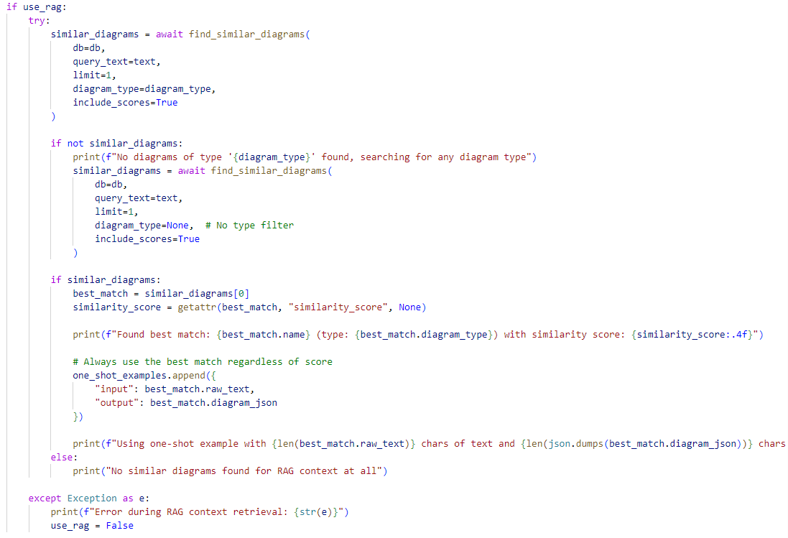
Image 5. RAG context retrieval logic that selects the most semantically similar diagram from the vector database and injects it into the AI prompt as a one-shot example.

Through this retrieval mechanism, the system reduces hallucination and increases alignment between the user's description and the resulting diagram structure.

  - Frontend Implementation
The frontend of the system is developed using the React framework, with additional support from the ReactFlow library for diagram visualisation and manipulation. Its design focuses on providing users with a smooth and highly interactive experience when working with SysML diagrams.

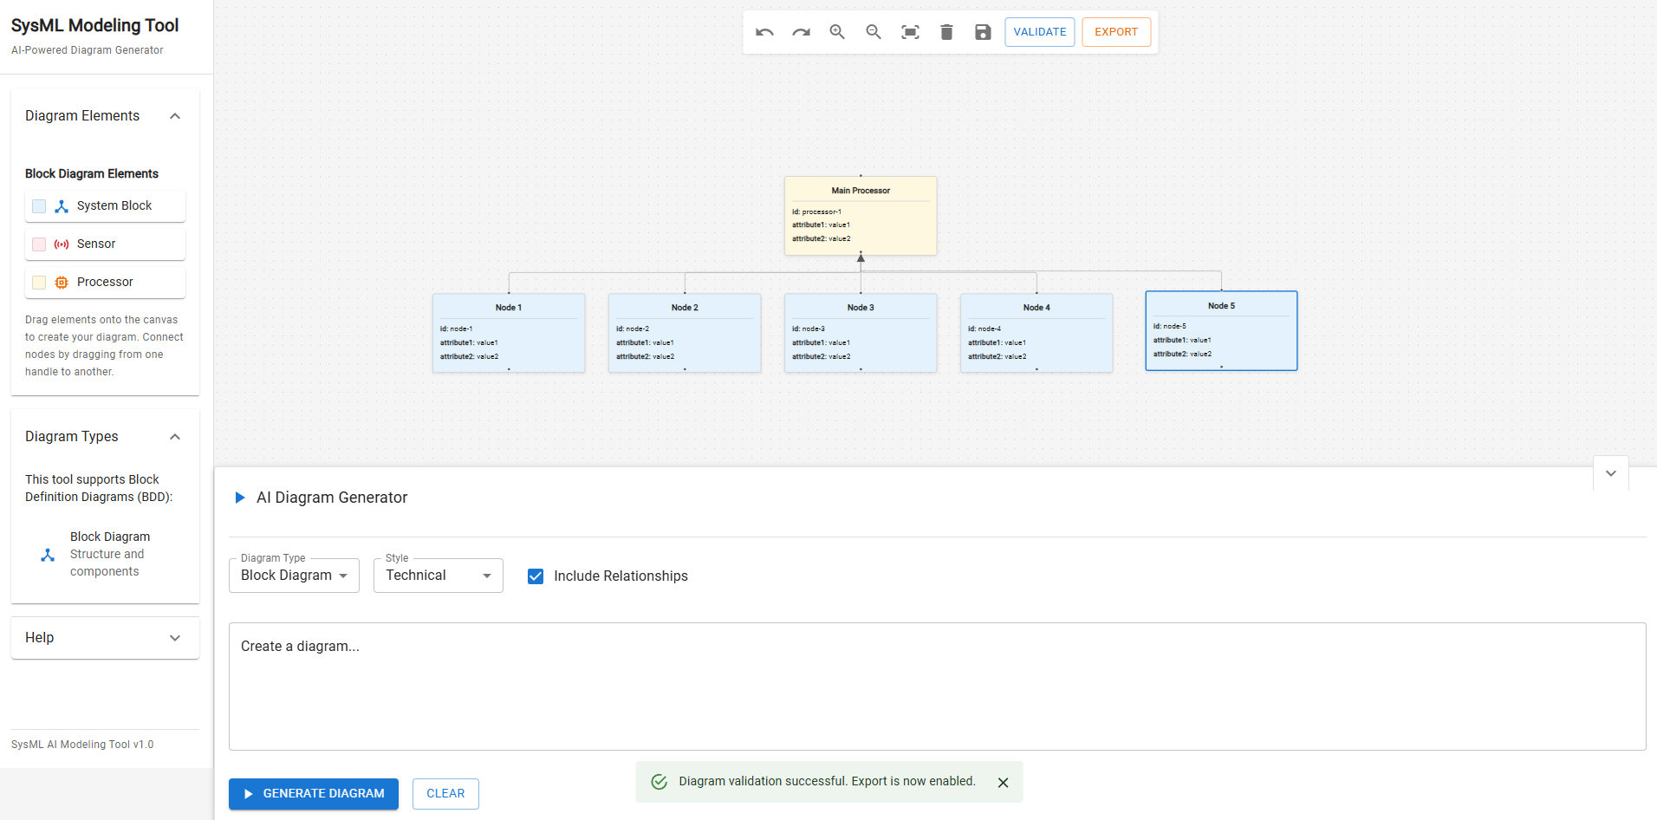
Image 6. Frontend interface which enables users to input system descriptions and generate structured SysML diagrams with editable visual output.

The principal of these is DiagramGeneratorNew, which enables users to enter in natural language descriptive texts about computers. This component is responsible for controlling various states in the process of generation, such as initiating requests to backends, handling loading sequences and providing visual feedback during processing. Its contributory elements help to make the generation interface responsive and user-friendly to such a degree that throughout their design processes users will always know what is going on.
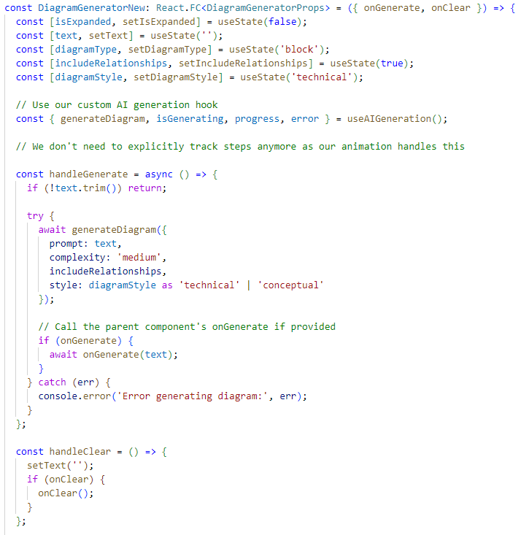
Image 7. DiagramGeneratorNew React component implementation, handling natural language input, state management, and AI-based diagram generation logic.

At the heart of the diagram editing functionality is the Canvas component, It renders generated diagrams and allows users to interact directly with every element. Users can move, resize, connect or delete diagram nodes and their relationships by intuitive mouse movements. When necessary, the layout can be adjusted manually–giving users full control over when the visual structuring takes shape.
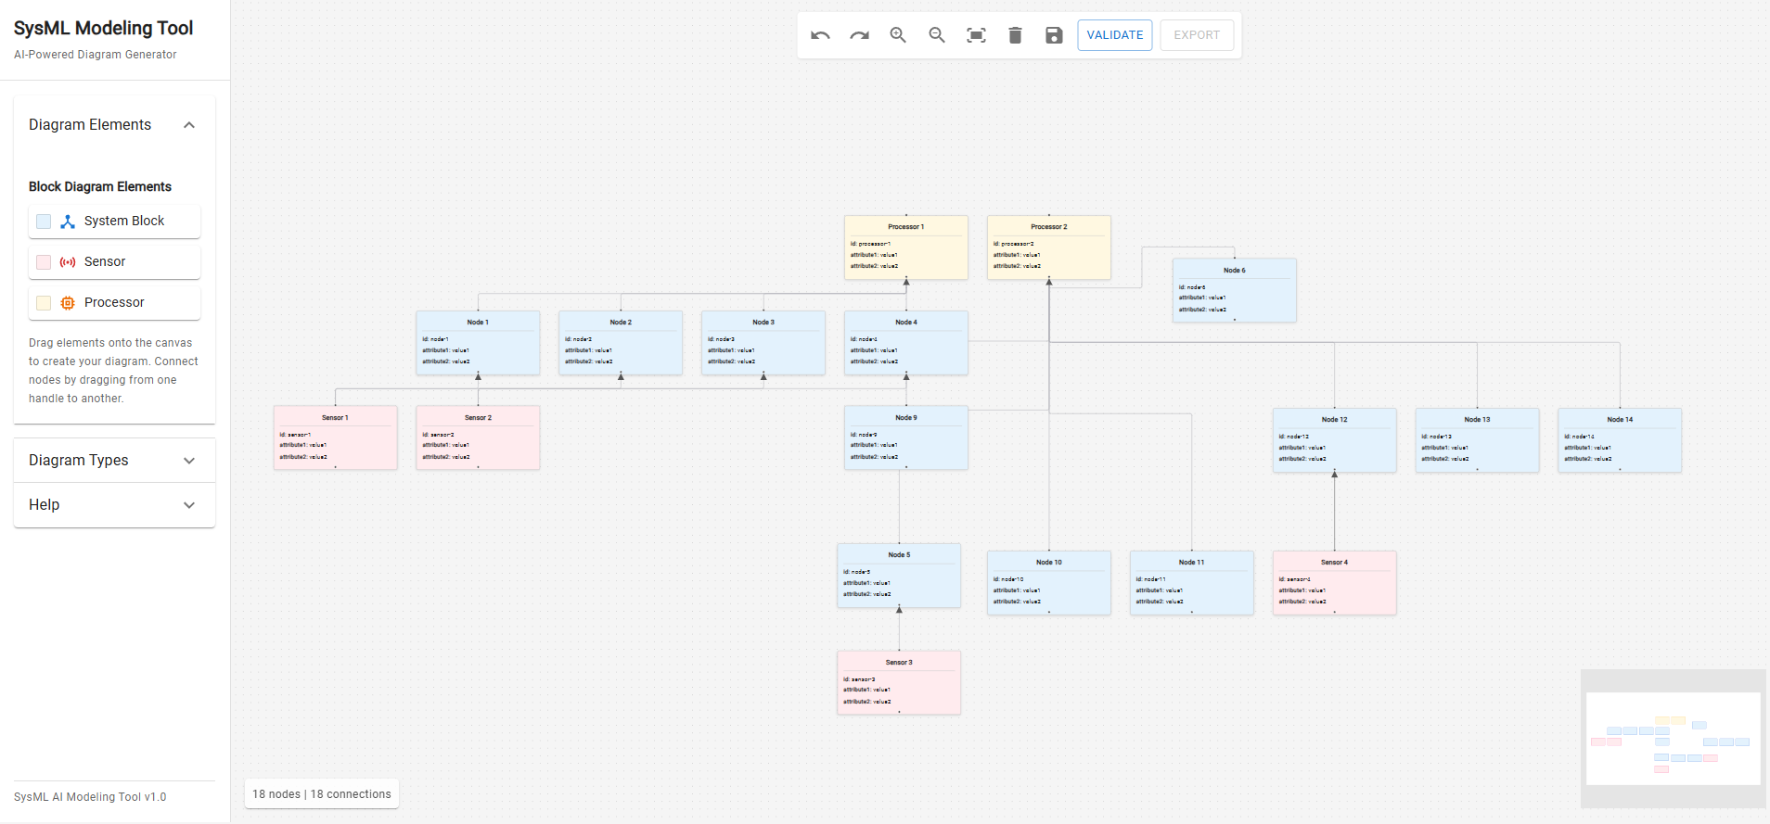
Image 8. Canvas component displaying a fully generated SysML diagram with support for manual editing, visual alignment, and interaction with nodes and edges.

Structured JSON data of the diagram’s nodes, edges and their properties is sent from the back-end to front-end. This JSON is dynamically parsed and translated through ReactFlow ’s rendering engine into visual components which users can see. In the transformation procedure each component is positioned and styled correctly according to the system’s visualities rules.
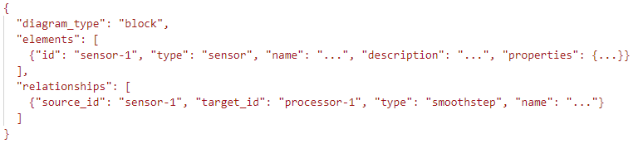
Image 9. Example of the JSON structure received from the backend, containing diagram elements and their relationships, used for dynamic rendering in the frontend.

Besides being able to generate diagrams automatically, the front end also allows the user manually to customize and refine the output. Such flexibility is essential for everyday use in an engineering environment, where very frequently diagrams that have been generated nonoptimal end up being used.
  - Database Design
The backbone of the system is PostgreSQL that provides a structured and efficient storage way to store data from submitted textual descriptions as well as generated diagram structures (represented in JSON form).
A major aspect of the database design is its provision for the process of Retrieval-Augmented Generation (RAG). The system creates embeddings of text descriptions submitted by users so as to support semantic search. These embeddings are stored in a dedicated column within our database, it uses vector data type supported by an extension to PostgreSQL called pgvector. This design permits rapid similarity-based query processing when one is seeking relevant examples.
Each entry in the main diagram table contains three key components:
- The original text that the user input
- The vector embeddings generated from this text
- The resultant diagram structure in JSON format
In this way, when the RAG module performs a semantic search it recovers not only input that are textually similar but also their corresponding diagram data in JSON format. It is therefore possible to give the system and AI model both a lexically similar description and an exact example of what must be constructed -- matters concerning generation quality are improved significantly.
It is designed for performance and scalability as well as being consistent. Indices have been placed on both vector embeddings and any relevant metadata fields to support efficient access at retrieval time. Schema normalization has only been carried out where this is appropriate.

  - AI and NLP Pipeline
The system's central component is an AI and natural language processing (NLP) pipeline. It translates user-contributed natural language descriptions into structured representations on SysML diagrams. The pipeline incorporates both generative and embedding models and makes extensive use of OpenAI's APIs.
At the heart of the generation process, we have a carefully engineered prompt template. This template determines the format, structure, and required detail. The system standardizes the form of the prompts, thus ensuring that output is consistent when used in different contexts and conforms to syntax needed for parsing into valid SysML components.
One-shot learning is utilized in the pipeline to enhance the quality and relevance of generated diagrams. This entails including a single high-quality example in the context guidelines of a prompt obtained from the RAG mechanism. The technique erases and heightens precision with this approach, as precise language models learn how they should word their output for incorporation into existing topics and several types of complex sentences.
In addition, the pipeline also generates vector embeddings of user input. These embeddings will be used for semantic similarity search to enable the RAG module to bring up contextually relevant past examples. Good-quality generation of embeddings is extremely important since it will directly determine the accuracy and utility of those examples which are selected for each new diagram generated independently.
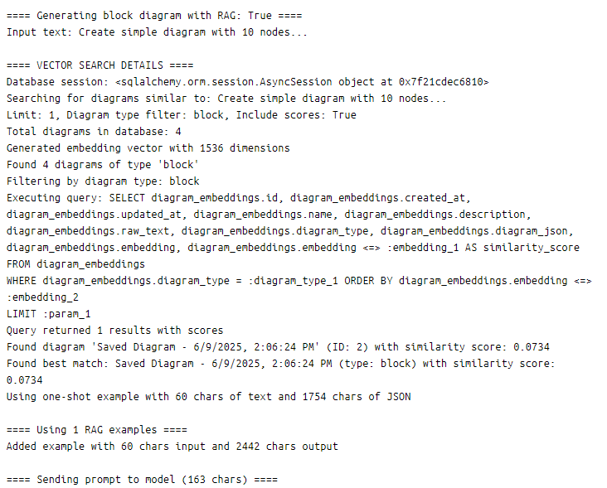
Image 10. Console output showing embedding-based retrieval during the RAG process, including similarity scores, selected example metadata, and prompt preparation details.

So the AI and NLP pipeline links together as many as multiple stages splitting data into earlier stages with domain knowledge and then finally producing diagrams that are both meaningful and spurious.

  - Docker-Based Deployment
When a system grows, there might be difficulty in keeping track of all the required components.
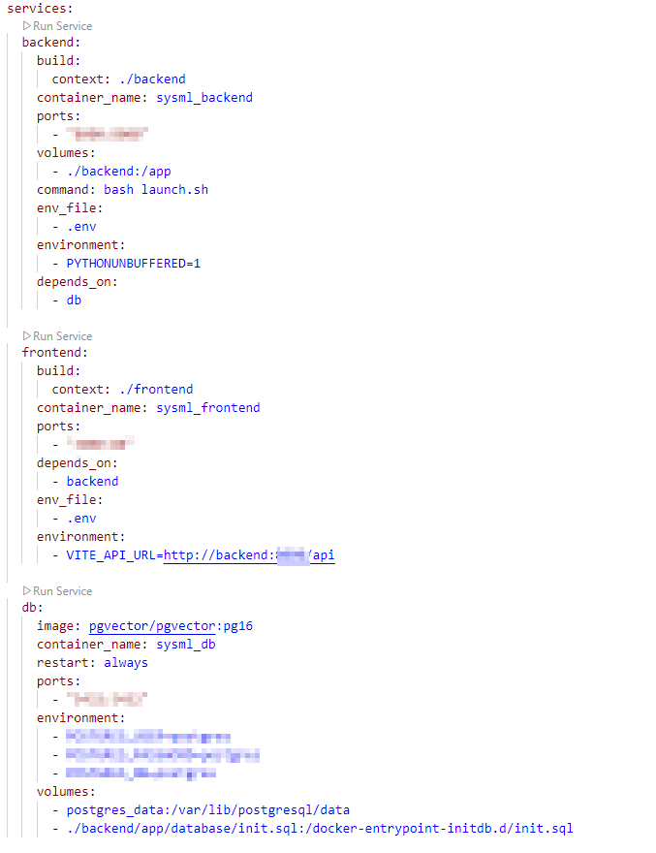
Image 11. Docker Compose configuration defining isolated services for backend, frontend, and PostgreSQL with pgvector extension, supporting modular and reproducible deployment.

Using Docker means composing the system with containers, and using Docker Compose for orchestration. This approach has the benefit that the back-end, front-end, and database services can all run in separate environments, each isolated as well as self-contained. In turn, this makes it possible to deploy the system reliably and consistently across different machines and development stages.
So far what we present is a kind of Day-1 configuration. Should it meet all your needs first then that is lucky indeed! If there are no further modifications required throughout your usage once deployed to production area, then indeed you have been lucky.
Each core component of the system is defined as a separate service in the Docker Compose configuration: for example, the back end container includes a FastAPI application plus its dependencies. The front end is a React-based user interface, with its own container. And there's PostgreSQL storage service with the pgvector extension installed by default for semantic vector operations in digital media data management.
By controlling the Docker environment for each service we guarantee reproducibility. Everything depends on Dockerfiles: All dependencies, configurations and runtime settings are explicitly stated. Troubles arising from differences in development settings between local machines-and-production sites can be avoided this way.
The orchestration provided by Docker Compose simplifies multi-service management. It allows developers to start, stop, and monitor all services with a single command. This setup also makes it easier to scale individual components, such as increasing resources for the backend API server or substituting the database with a managed instance in a production environment.
In addition, this containerised approach improves maintainability. Updates can be rolled out to individual components without affecting the rest of the system.

  - Conclusion
This project's system showcases both a fruitful and pioneering requirement--to automatically set up SysML diagram software from natural language input. It uses modern web technology, advanced artificial intelligence models, along with efficient database architecture in order to streamline the program.
The result is a greatly reduced work routine that impactfully simplifies systems engineering tasks for most users. Toward these goals, the system interfaces with GUI support for both newcomers and experts. It includes a help chapter to guide you as you create your diagrams, also offering facilities to export SysML diagrams.
This approach then offered additional flexibility: models created by others ahead of time can now be re-used, revised, or extended right inside the same environment. By combining AI-driven generation with manual editing facilities, the system allows both flexibility and precision.
Furthermore, the RAG mechanism furnishes examples to the language model that are contextually meaningful and thus helps improve the quality of outputs. The back-end's modular architecture and Docker-based deployment enable scalability, portability and maintenance. Constraints of the present model are that it slows when heavily loaded on processing and for complex diagrams it becomes difficult to carry out generation. Nevertheless, this system provides a stable basis for future work.
This future work will focus on technical improvement, increasing the scope of customization and collaboration. This project makes a clear contribution to the paradigm shift taking place right now, from traditional manual descriptive methods to new forms of modelling with AI support. People can see that intelligent systems already increasingly support complex technical activities as those in systems engineering, and get some insight into those more automated and collaborative design environments of generations to come.

